{{OUR_LEGAL}} 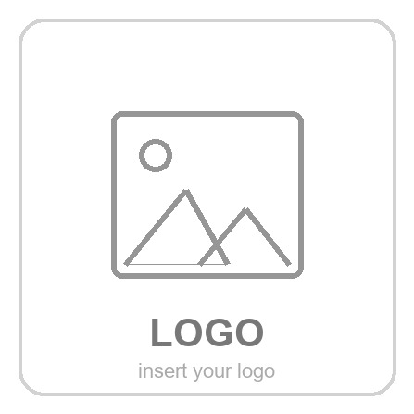
{{PROJECT_NAME}}
MEETING MINUTES No. [no.]

WRITTEN BY | {{AUTHOR}}
DATE | [dd-mm-yyyy]
COORDINATED BY | {{BIM_COORDINATOR}}
ATTENDEES | {{TEAM_ATTENDEES}}
ABSENT | [Name Surname]  [Name Surname]
PLACE / MEDIUM | [e.g. Videoconference — Google Meet]
TIME | [hh:mm]
AGENDA / TOPICS DISCUSSED | - [Topic 1]  - [Topic 2]  - [Topic 3]  - [Topic 4]
CONCLUSIONS / AGREEMENTS | - [Conclusion / agreement 1]  - [Conclusion / agreement 2]  - [Conclusion / agreement 3]  - [Conclusion / agreement 4]
- NEXT MEETING
Working protocol: MC applies the publicly verifiable direction of ISO/DIS 19650-1 and ISO/DIS 19650-2 (2026 drafts) to project information management. ISO 19650-1:2018 and ISO 19650-2:2018 remain the published references until replaced. The appointment and applicable national adoption determine contractual obligations. Generation does not constitute review, authorization, acceptance or certification.
The next meeting:

F.01
F.02
F.03
F.04
F.05
F.06
F.07
F.08
F.09
F...
F...
F.10
F.11

- NEXT MEETING
The next meeting:
- NEXT MEETING
The next meeting:
- NEXT MEETING
The next meeting:

DATE | [dd/mm/yyyy]
PLACE / MEDIUM | [e.g. Videoconference — Google Meet]
TIME | [hh:mm]

